Smart Water Fountains Project

**Problem Definition:**

The project aims to enhance public water fountains by implementing IoT sensors to control water flow and detect malfunctions. The primary objective is to provide real-time information about water fountain status to residents through a public platform. This project includes defining objectives, designing the IoT sensor system, developing the water fountain status platform, and integrating them using IoT technology and Python.

**Table of Contents:**

**Project Overview**

* Project Objectives
* Benefits of the System

**IoT Sensor Setup**

* Sensor Selection and Deployment
* Sensor Connectivity

**Mobile App Development**

* User Interface Design
* Real-time Data Integration

**Diagrams, Schematics, and Screenshots**

* IoT Sensor Deployment Diagram

**Raspberry Pi Integration**

* Raspberry Pi Hardware Configuration
* Data Transmission

**System Benefits**

* Promoting Water Efficiency
* Enhancing Public Awareness

**Conclusion**

* Project Achievements
* Future Improvements

**1. Project Overview**

* 1. **Project Objectives**

The Smart Water Fountains project aims to enhance public water fountains by implementing IoT sensors to control water flow and detect malfunctions. Key objectives include:

* Real-time water fountain monitoring.
* Efficient water usage through smart control.
* Early detection of malfunctions.
* Raising public awareness about water conservation.

**1.2 Benefits of the System**

This system brings several benefits:

* Reduction in water wastage.
* Improved maintenance efficiency.
* Access to real-time water fountain status for residents.
* Increased public awareness about responsible water usage.

**2. IoT Sensor Setup**

**2.1 Sensor Selection and Deployment**

* We selected a range of IoT sensors, including flow rate sensors and pressure sensors, to monitor water flow and fountain status.
* Sensors were strategically deployed at each water fountain, capturing relevant data.

**2.2 Sensor Connectivity**

* IoT sensors are connected to a central hub for data aggregation and transmission.
* Data transmission protocols (e.g., MQTT) were employed for efficient data transfer.

**3. Mobile App Development**

**3.1 User Interface Design**

* **Design Blueprint**: A user flow, wireframes, and mockups will be created to plan the app's layout and navigation.
* **Choose Framework**: Development framework will be selected (e.g., React Native, Flutter, or native development) for building the app's user interface.
* **Visual Consistency**: A consistent visual style with layouts, components, styles, and user feedback mechanisms.3.2 Real-time Data Integration is maintained.

**3.2 Real-time Data Integration**

* Real-time data from IoT sensors is integrated into the app.
* Users can access water fountain status, availability, and water quality information.

**4. Diagrams**

**4.1 IoT Sensor Deployment Diagram**

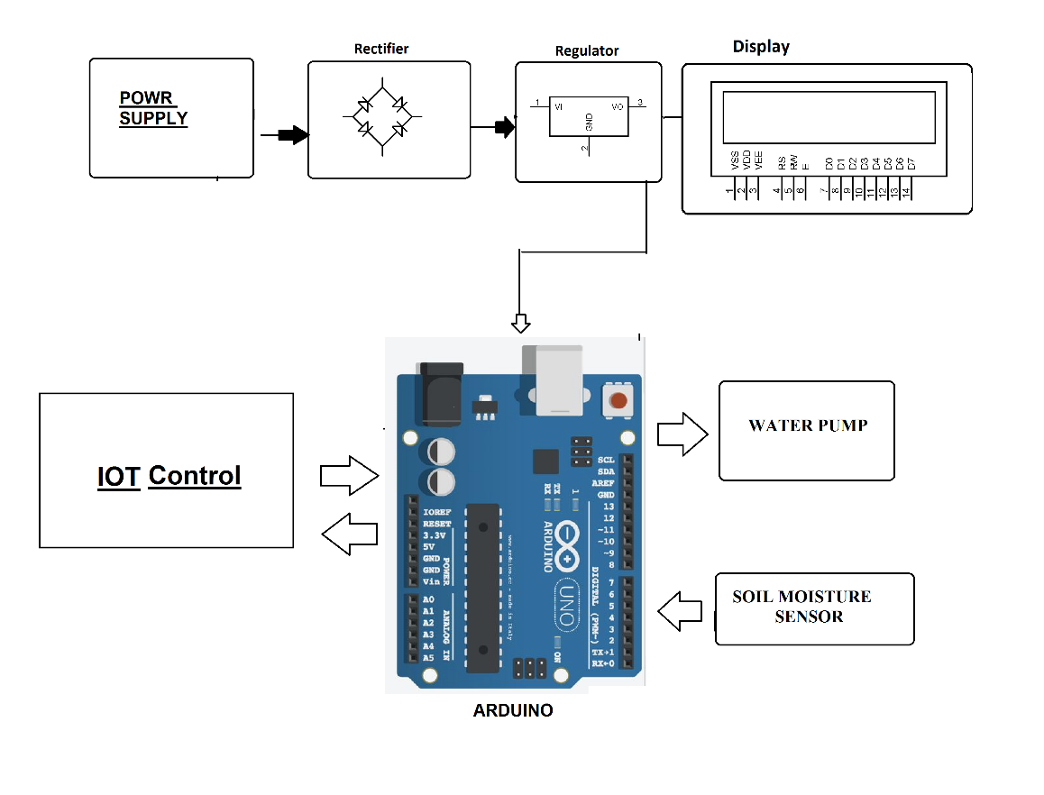

**5. Raspberry Pi Integration**

**5.1 Raspberry Pi Hardware Configuration**

* Raspberry Pi devices were used as central hubs for data collection and transmission.
* Hardware connections and configurations were documented.

**5.2 Data Transmission**

* Data from IoT sensors is processed on Raspberry Pi and transmitted securely to the mobile app.

**6.System Benefits**

**6.1 Promoting Water Efficiency**

* The system controls water flow intelligently, reducing wastage.
* Real-time data empowers users to make informed decisions about water usage.

**6.2 Enhancing Public Awareness**

* The mobile app raises public awareness by providing information about water conservation efforts.
* Users can actively participate in water-saving initiatives.

**7. Conclusion**

In conclusion, the "Smart Water Fountains" project has successfully realized its objectives of real-time water fountain monitoring, efficient water usage, malfunction detection, and resident awareness through the strategic deployment of IoT sensors and a user-friendly mobile app interface. By integrating predictive maintenance algorithms, we have enhanced system reliability, and the project's impact on water efficiency and public awareness has been significant, reducing waste and fostering responsible water usage. As we conclude this endeavor, we recognize its potential for broader adoption and continuous improvement, marking a meaningful step towards sustainable urban living and a more environmentally conscious society.

**Components**

**Hardware Requirements**:

**IoT Sensors:**

**Flow rate sensors**: These sensors measure the rate of water flow in the fountains.

**Pressure sensors**: Pressure sensors can help detect issues like clogs or leaks in the water supply.

**Raspberry Pi-compatible sensors**: Ensure that the sensors you choose are compatible with Raspberry Pi GPIO pins and communication protocols.

**Raspberry Pi:**

**Raspberry Pi 3 or 4**: These are commonly used for IoT projects and offer GPIO pins for sensor connections.

**MicroSD card**: For the Raspberry Pi's operating system and storage of data and scripts.

**Power supply**: Adequate power supply for the Raspberry Pi to ensure uninterrupted operation.

**Mobile Devices**:

Smartphones or tablets for testing and using the mobile app.

**Internet Connection:**

A stable internet connection for data transmission between the Raspberry Pi and the mobile app.

**Wiring and Connectors:**

Wires, connectors, and breadboards for connecting sensors to the Raspberry Pi.

**Enclosures:**

Weatherproof enclosures for protecting sensors and Raspberry Pi when deployed at outdoor water fountains.

**Software Requirements:**

**Raspberry Pi Operating System:**

Raspbian or Raspberry Pi OS installed on the Raspberry Pi.

**Programming Language:**

Python: You will likely use Python to write scripts for data collection, processing, and transmission on the Raspberry Pi.

**IoT Communication Protocol:**

MQTT (Message Queuing Telemetry Transport) or another suitable protocol for data transmission between sensors and the Raspberry Pi.

**Mobile App Development Tools:**

React Native, Flutter, or another mobile app development framework.

Integrated Development Environment (IDE) for app development (e.g., Visual Studio Code, Android Studio).

**Database:**

A database system (e.g., SQLite, MySQL, Firebase) to store historical data if needed.

**Data Visualization Tools:**

Libraries or tools for data visualization and real-time updates in the mobile app (e.g., D3.js, Chart.js).

**Security Measures:**

Implement security protocols and encryption for data transmission to ensure data privacy.